**iKnow the Music**

|  |  |
| --- | --- |
|  | Student’s Task |

**You have been selected by the music research firm, iKnow, to do an in-depth analysis of a large ensemble piece of music. The range of topics they are interested in gathering include:**

* **History of the music/composer (optional for Elementary)**
* **Key signature/s**
* **Time signature/s**
* **Music terminology used**
* **Common rhythms within the piece**
* **Form**
* **A brief commentary/criticism on the music (optional for Elementary)**

**Your response is crucial in helping directors around the world to choose music that will better suit their ensembles!**

Your Task

**First, analyze the piece of music —**

The music research firm explains that you must meet the following requirements when analyzing your music:

* Choose from the list of songs that you will be performing for the next concert/festival. These will be pieces of music that your director has provided.
* Throughout the course of learning the music take note of the following information:
  + History/Facts about the piece of music
  + Key Signature
  + Time Signature
  + Musical Terminology used
  + Common Rhythms used
  + Musical Form
  + Your personal response to the music

|  |  |
| --- | --- |
|  | Assessment Rubric |

|  |  |  |  |  |  |
| --- | --- | --- | --- | --- | --- |
| ***iKnow the Music*** | | | | | |
|  | **4 – Exceeding Standard** | **3 – Meeting Standard** | **2 – Approaching Standard** | **1 – Basic Understading** | **No Score** | |
| **Responding** | Demonstrates understanding of ALL concepts (context/elements of music) when responding to the music. | Demonstrates understanding of MOST concepts (context/elements of music) when responding to the music. | Demonstrates understanding of SOME concepts (context/elements of music) when responding to the music. | Demonstrates understanding of FEW concepts (context/elements of music) when responding to the music. | Has yet to respond. | |

**Scoring Notes**

Please note that this rubric should be used for each topic/element analyzed in the piece (ie, History, key signature, time signature, music terminology, rhythms, form, personal response). Students can thus earn up to 7 scores with this assessment.

The following scoring notes should be used as a guideline when scoring this item.

* 4, or Exceeding Standard – The student shows complete 100% knowledge of the element or concept and may even show knowledge going beyond the piece of music.
* 3, or Meeting Standard – The student shows understanding of more than half of the knowledge of the elements or concepts for the piece of music.
* 2, or Approaching Standard – The student shows understanding of less than half of the knowledge of the elements or concepts for the piece of music.
* 1, or Basic Understanding – The student shows very little knowledge of the elements or concepts for the piece of music.

|  |  |
| --- | --- |
|  | Response Sheets |

**Student’s Name/ID# _____________________________________________ Grade Level _________**

|  |  |  |
| --- | --- | --- |
| **(circle number)** | **Responding Score** | **4 3 2 1 NS** |

Responses

iKnow___________________(Title/Composer)

Your Name/Instrument___________________________

**History/Facts**: Write about the style of music, composer, history, or any facts about this music

**Key Signatures**: Circle *your* key signature and underline whether it is **Major or Minor.**

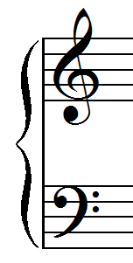 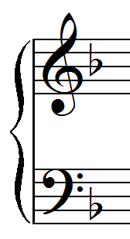 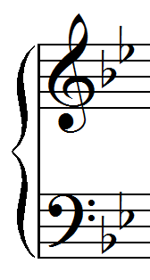 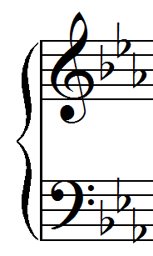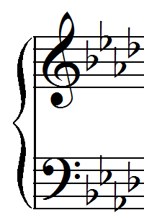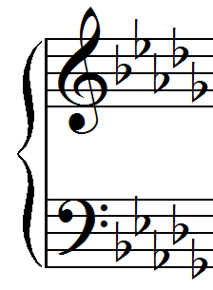 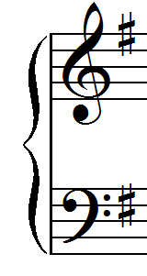 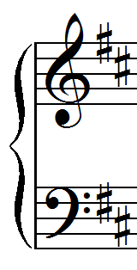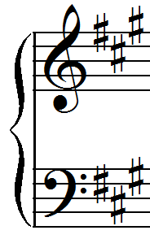

C Major F Major Bb Major Eb Major Ab Major Db Major G Major D Major A Major

A Minor D Minor G Minor C Minor F Minor Bb Minor E Minor B Minor F# Minor

**Time Signatures**: Circle all that are in your music ***and write what they mean.***

 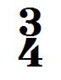      

**Music Vocabulary/Symbols:** Write down the names of the symbols ***and their meaning****.*

|  |  |  |  |
| --- | --- | --- | --- |
| **Vocab./Symbol** | **Definition** | **Vocab./Symbol** | **Definition** |
|  |  |  |  |
|  |  |  |  |
|  |  |  |  |
|  |  |  |  |
|  |  |  |  |
|  |  |  |  |

**Rhythms:** Choose up to the 10 most challenging measures of rhythm from your music. Write how to count them.



**Form**: Write out the form of the music. Is there a special name for this form?